Service Note Daily WM RES CalAIM 22-07 Changes Clinicians Gateway 2022-July

Changes Made:
- (Billing header remains unchanged)
- Instructions updated
- Treatment Plan Objectives removed
- Service Type drop down updated
- Start and End Times removed
- Location removed
- Description of Service text box changed to “Comments (Optional)”
- Added text boxes for Daily Narrative and Next Steps.
- (Documentation Time Log remains unchanged)

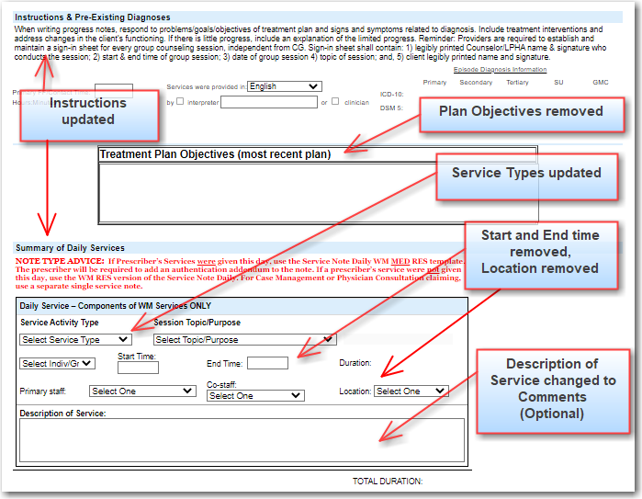

The CalAIM version of the Service Note Daily WM RES
